**Complete installation guide for Kubernetes.**

This is specially for people who get error **“The connection to the server localhost:8080 was refused - did you specify the right host or port?”**

Step 1:

Go to official Kubernetes website and follow the installation guide as in link below (For Linux)

[Install and Set Up kubectl on Linux | Kubernetes](https://kubernetes.io/docs/tasks/tools/install-kubectl-linux/#install-kubectl-binary-with-curl-on-linux)

1. curl -LO [https://dl.k8s.io/release/$(curl -L -s https://dl.k8s.io/release/stable.txt)/bin/linux/amd64/kubectl](https://dl.k8s.io/release/$(curl%20-L%20-s%20https://dl.k8s.io/release/stable.txt)/bin/linux/amd64/kubectl)

The above command will download the kubectl binary file to you system

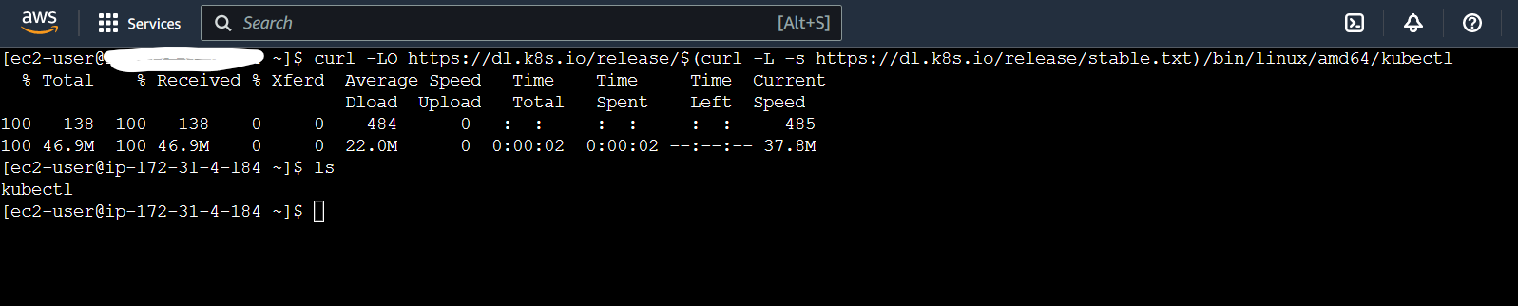

1. curl -LO [https://dl.k8s.io/$(curl -L -s https://dl.k8s.io/release/stable.txt)/bin/linux/amd64/kubectl.sha256](https://dl.k8s.io/$(curl%20-L%20-s%20https://dl.k8s.io/release/stable.txt)/bin/linux/amd64/kubectl.sha256)

The above command will download the checksum file which will validate the binary file

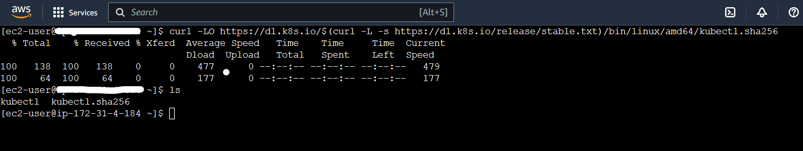

1. echo "$(cat kubectl.sha256) kubectl" | sha256sum --check

The above command will validate the kubectl installation and give below output

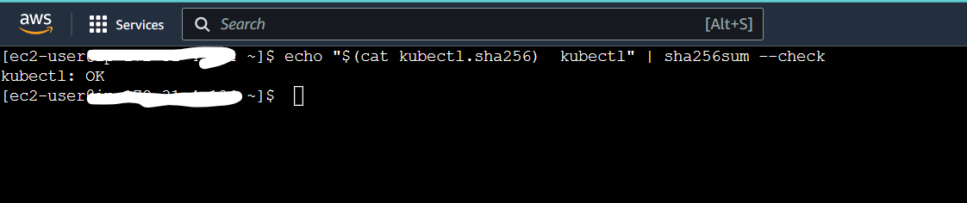

OUTPUT (kubectl: OK)

1. chmod +x kubectl (This will change the kubectl file as executable

mv kubectl /bin (To move executable kubectl file to /bin directory)

now move to /bin directory with cd /bin command

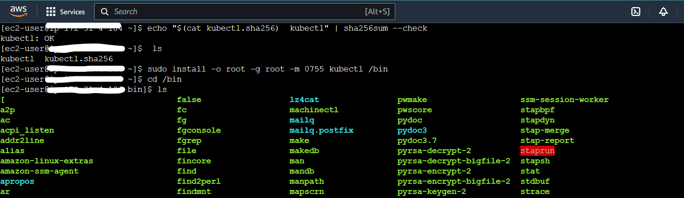

Then use the cd /bin to check whether kubectl is in the directory as below

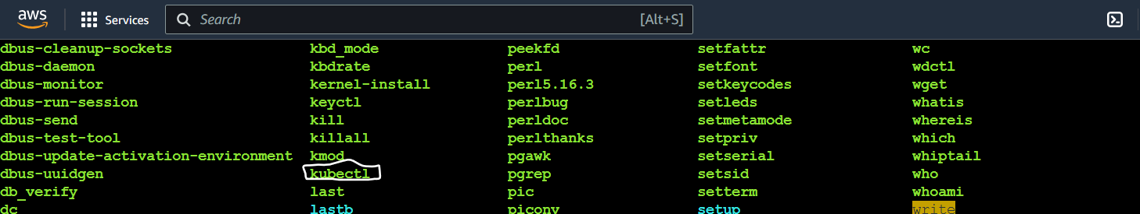

The above command will move kubectl to /bin directory

FYI: In Amazon EC2 the /bin directory is where all the executable files are stored

1. Now run the command

kubectl version –client or kubectl version --client --output=yaml

The above commands will give you kubectl version details.

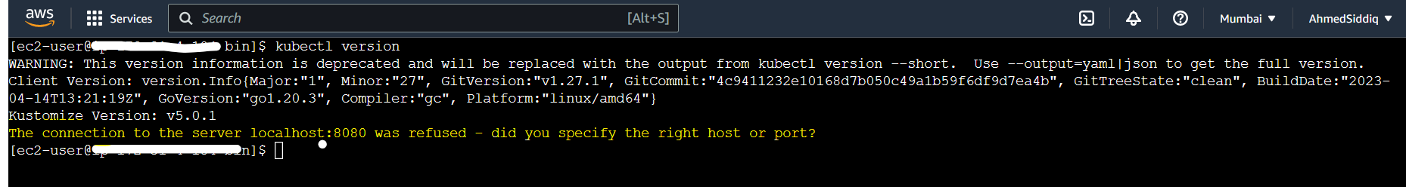

As you can in the highlighted (Yellow) region I am still getting the error. Need to follow below steps.

1. Now we will install kubeadm, kubelet, kubectl (We have already installed kubectl in the above commands
2. Copy the below command and paste in the terminal

cat <<EOF | sudo tee /etc/yum.repos.d/kubernetes.repo

[kubernetes]

name=Kubernetes

baseurl=https://packages.cloud.google.com/yum/repos/kubernetes-el7-\$basearch

enabled=1

gpgcheck=1

gpgkey=https://packages.cloud.google.com/yum/doc/rpm-package-key.gpg

exclude=kubelet kubeadm kubectl

EOF

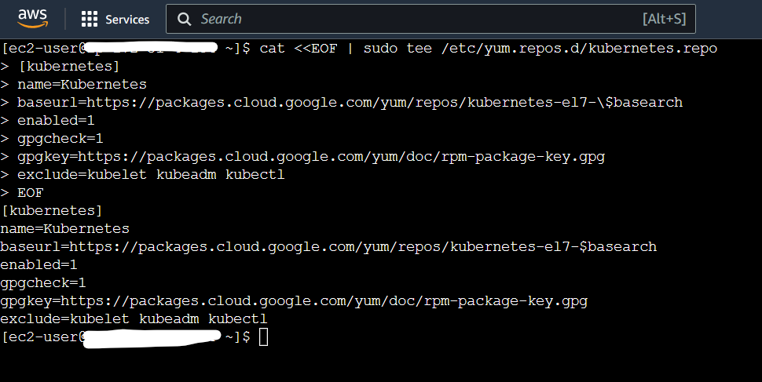

1. Now run the below commands one by one

# Set SELinux in permissive mode (effectively disabling it)

sudo setenforce 0

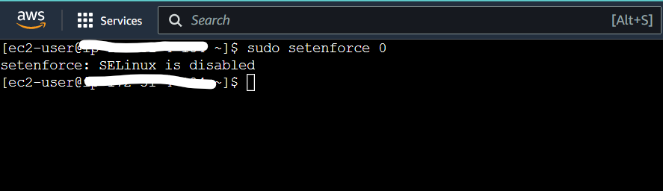

sudo sed -i 's/^SELINUX=enforcing$/SELINUX=permissive/' /etc/selinux/config

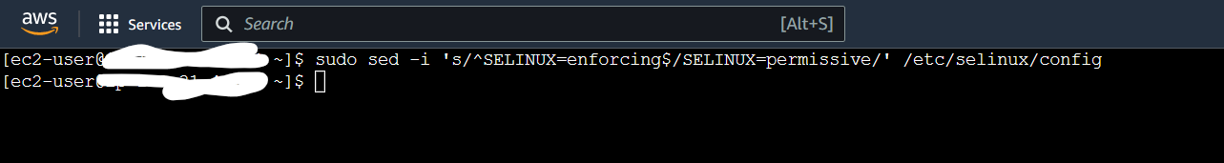

sudo yum install -y kubelet kubeadm kubectl --disableexcludes=Kubernetes

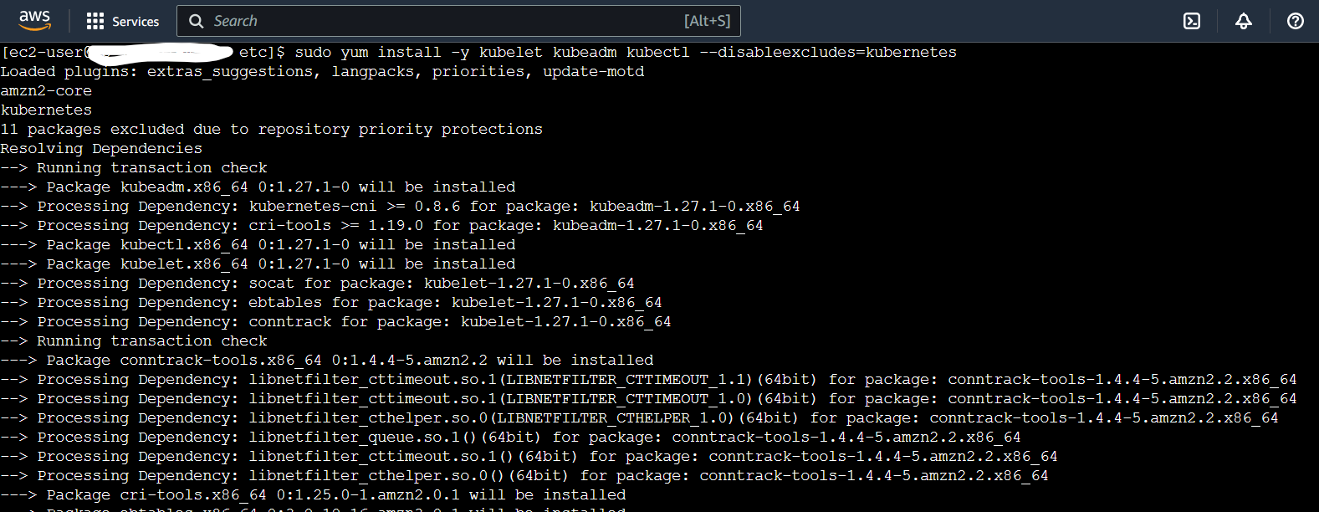

After that run sudo systemctl enable --now kubelet

Now run “kubeadm init” or “sudo kubeadm init”

Make sure you have more than 2Gib of RAM and 1700 MB for free memory

Orelse the kubeadm init command will show fatal error message

After this do cd/etc and check for Kubernetes directory and the do

cd /etc/Kubernetes

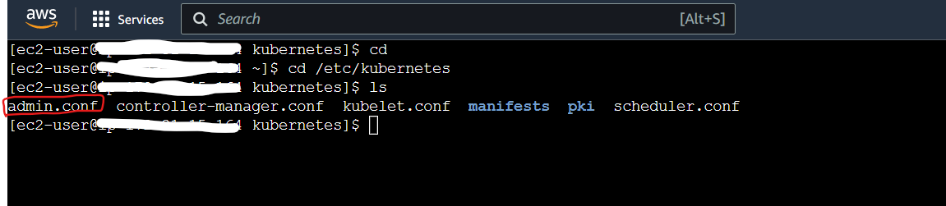

1. After the above commands when we run the “kubectl get pod” command we will still get the error “The connection to the server localhost:8080 was refused - did you specify the right host or port?”

This error is because the .kube directory is not created and does not have .config file.

To resolve it follow below steps

1. We can get the admin.conf file from /etc/Kubernetes/admin.conf

1. For this we need to first initiate the kubeadm using the command as “kubeadm init” also you can use “sudo kubeadm init”
2. This will create the admin.conf file in the /etc/Kubernetes location
3. Since we do not have a config file in kubectl to check use command as “kubectl config view” it will be empty as below

apiVersion: v1

clusters: []

contexts: []

current-context: ""

kind: Config

preferences: {}

users: []

1. Now create a .kube directory in home as below

sudo mkdir .kube

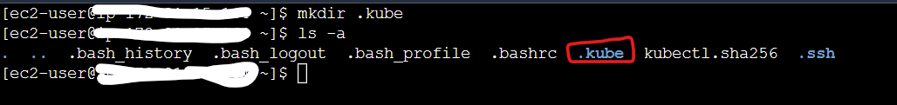

sudo cp /etc/kubernetes/admin.conf ~/.kube (you need to run the command from home directory)

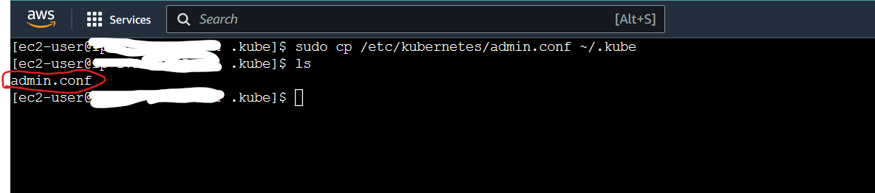

The above command will copy the admin.conf file from /etc/Kubernetes to .kube

Use command to check .kube directory (cd .kube)

sudo mv admin.conf config (This will move the file to default config directory)

make sure you are in .kube directory while running the command.

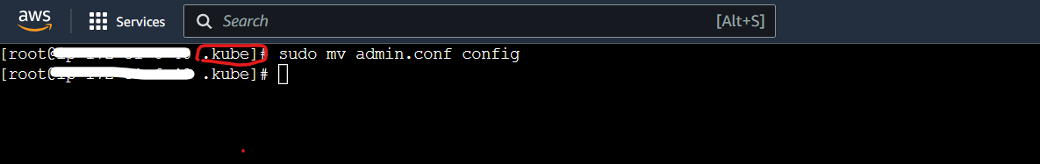

sudo service kubelet restart

1. Now when we run the command “kubectl get pod” we do not get the error “The connection to the server localhost:8080 was refused - did you specify the right host or port?”

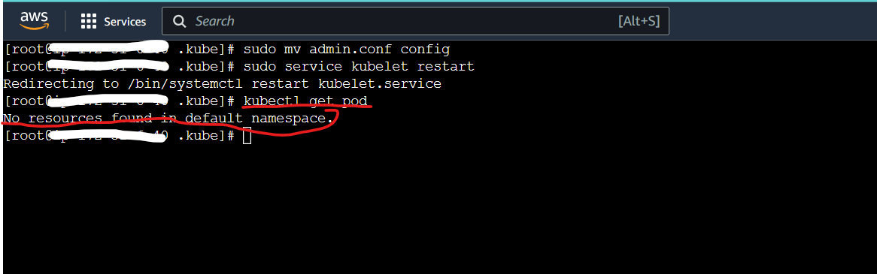

As in the highlighted space you can see we are not getting error now.